** Question/Answer Booklet**

**Name: MEMO**

**PHYSICAL EDUCATION STUDIES YEAR 11 ATAR**

**Semester 1 Exam 2020**

**Time allowed for this paper**

Reading time before commencing work: 0 minutes

Working time for paper: 2 Hours

***To be provided by the candidate***

Standard items: pens (blue and black), pencils, eraser, correction fluid, ruler, highlighter

**Important note to candidates**

No other items may be taken into the examination room. It is **your** responsibility to ensure that you do not have any unauthorised notes or other items of a non-personal nature in the examination room. If you have any unauthorised material with you, hand it to the supervisor **before** reading any further.

**Structure of paper:**

|  |  |  |  |
| --- | --- | --- | --- |
| Section | Number of questions available | Number of questions to be attempted | Marks available |
| **Section One:**  Multiple-Choice | 20 | 20 | 20 |
| **Section Two:**  Short Answer | 15 | 15 | 60 |
| **Section Three:**  Extended Answer | 3 | 2 | 20 |
|  |  |  | **100** |

Answer the twenty **(20)** Multiple-Choice questions on the separate Multiple-Choice answer sheet provided.

**Multiple Choice (20 marks)**

1. There is approximately 100,000 kilometres of blood vessels, comprising of arteries, veins and capillaries in every adult athlete. Which of the following is **not** a characteristic of arteries?

(a) Carries blood away from the heart.

(b) Thick elastic walls permit continuous blood flow.

(c) Blood flow is created by the beating of the heart.

(d) Blood flow is created by the contraction of muscles.

1. The origin point for the hamstring muscle group is located on the:

(a) Pelvis.

(b) Femur.

(c) Tibia.

(d) Fibula.

1. The appendicular skeleton assists the human body to create movement. Which of the following bones are part of the appendicular skeleton:

(a) Ulna, Radius, Sternum.

(b) Humerus, Pelvis, Fibula.

(c) Femur, Metacarpals, Scapula.

(d) Tarsals, Phalanges, Coccyx.

1. In the action of kicking and making contact with a football, the leg and the agonist muscle group is the .
2. Extends, Gluteals.
3. Flexes, Quadriceps.
4. Flexes, Hamstrings.
5. Extends, Quadriceps.
6. Skeletal muscle tissue has many characteristics, which aid in the production of movement. In gymnastics, the ability for a muscle to stretch when a force is applied is critical to successfully performing choreographed routines. This is referred to as the muscles:

(a) Excitability.

(b) Contractibility.

(c) Extendibility.

(d) Elasticity.

1. General Motion is the most common form of motion in sporting activities and is best described as:

(a) Linear motion.

(b) Angular motion.

(c) A combination of linear and angular motion.

(d) The rotation around an axis.

1. Professional golfers know it is important for them to strike the ball as the club head is descending on the downswing. The application of maximal force when the club head makes contact with the surface of the golf ball just prior to reaching the bottom of the swing arc is an example of:

(a) Newton’s First Law of Motion.

(b) Newton’s Second Law of Motion.

(c) Newton’s Third Law of Motion.

(d) Newton’s Fourth Law of Motion.

1. Kyle Chalmers is the reigning Olympic Men’s 100m Freestyle gold medallist. In swimming his 100m event, Kyle increases his speed and then maintains this speed for as long as possible before eventually slowing down near or at the end of the race. When Kyle is maintaining his speed in the 100m, there is;

(a) Negative Acceleration.

(b) Positive Acceleration.

(c) Zero Acceleration.

(d) Constant Acceleration.

1. In netball, taller players often play in attacking and defending positions within the goal circle. Mid-court players will use a lob pass to clear a defending player in order to have the Goal Attacker (GA) or Goal Shooter (GS) receive the pass overhead. With this knowledge, which angle of projection would seem the most appropriate to perform a successfully lob pass?

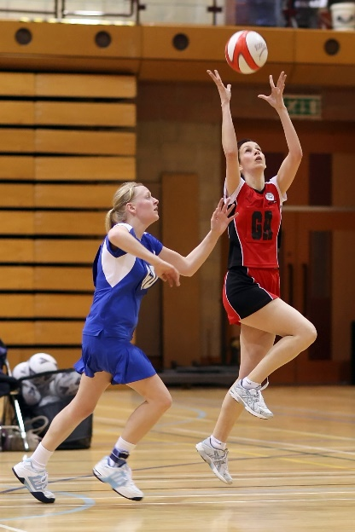

(a) 10 Degrees.

(b) 45 Degrees.

(c) 75 Degrees.

(d) 90 Degrees.

1. In a game of volleyball, players at the net defending will endeavour to ‘block’, jumping vertically before landing. By players bending their knees on landing, they reduce their chance of injury by increasing:

(a) Impulse.

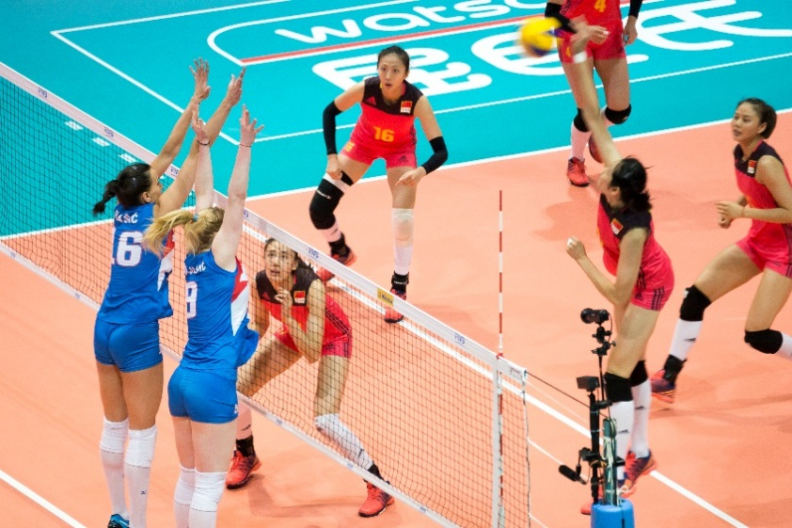 (b) Inertia.

(c) Momentum.

(d) Velocity.

1. Throwing a dart, as pictured below, can be classified as a:

(a) Discrete, Closed motor skill.

(b) Continuous, Open motor skill.

(c) Serial, Closed motor skill.

(d) Gross, Open motor skill.

1. Augmented feedback in which a coach provides information regarding the outcome or success of the movement to their athlete, is known as:
2. Specific feedback.
3. Knowledge of results.
4. Knowledge of performance.
5. Knowledge of feedback.
6. In an offensive play of NFL gridiron, the quarterback receives the ‘snap’ pass from the centre, then looks to throw the ball downfield to an eligible receiver who is covered by a defending player, the quarterback then decides to run with the ball himself. According to the information-processing model, what stage of the model did the quarterback reach?
7. Identification of stimuli/input.
8. Response identification/decision-making.
9. Response/output.
10. Feedback.
11. A ten-pin bowler who watches the ball spin and travel path down the lane before then hearing the ball strike into the pins is receiving:

1. Extrinsic feedback.
2. Augmented feedback.
3. Intrinsic feedback.
4. Knowledge of performance.

15. During an Inter-School basketball game, a coach shouts out to her players ‘zone defence’, as the ball is turned ovr from a rebound. This is an example of:

(a) Terminal feedback.

(b) Concurrent feedback.

(c) Constructive feedback.

(d) Intrinsic feedback.

16. Which of the following is not a characteristic of capillaries?

(a) Exchange carbon dioxide and oxygen.

(b) Have thin walls.

(c) Are microscopic.

(d) Have strong elastic walls.

17. Identify the joint movement performed by a swimmer’s shoulders during a backstroke race:

(a) Adduction.

(b) Flexion.

(c) Extension.

(d) Circumduction.

18. Which of the following statements about balance is TRUE?

(a) A lower centre of gravity and lower centre of mass decreases balance.

(b) A higher centre of gravity and higher centre of mass increases balance.

(c) A lower centre of mass and lower centre of gravity increases balance.

(d) A higher centre of mass and lower centre of gravity increases balance.

19. Sam’s swim coach calculates the average number of freestyle strokes she performs in a minute. This is a measure of Sam’s:

(a) Angular velocity.

(b) Angular acceleration.

(c) Angular speed.

(d) Angular distance.

20. Which of the following muscle groups are **not** antagonistic pairs?

1. Biceps, Triceps.
2. Trapezius, Deltoids.
3. Tibialis anterior, Gastrocnemius.
4. Gastrocnemius, Soleus.

**Short Answer (60 marks)**

This section has **Fifteen (15)** questions. Answer **all** questions. Write your answers in the spaces provided in this Question/Answer Booklet. Wherever possible, confine your answers to the line spaces provided. Use a blue or black pen (**not** pencil) for this section.

**Question 21 (5 marks)**

Identify the anatomical features within the right lung in the diagram below.

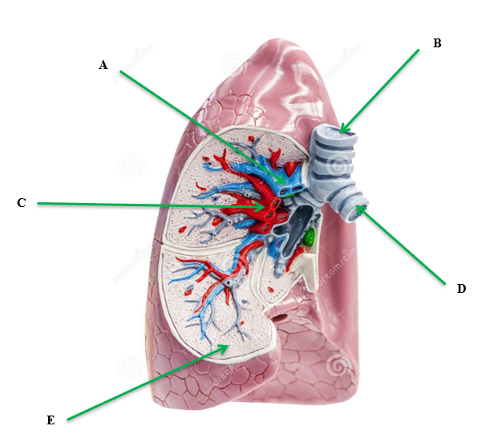

|  |
| --- |
| 1. Pulmonary Artery |
| 1. Trachea |
| 1. Pulmonary Vein |
| 1. Bronchi |
| E. Alveoli |

**Question 22 (3 marks)**

In the image below, identify the joint movement of the shoulder, elbow and wrist in pitching the baseball.

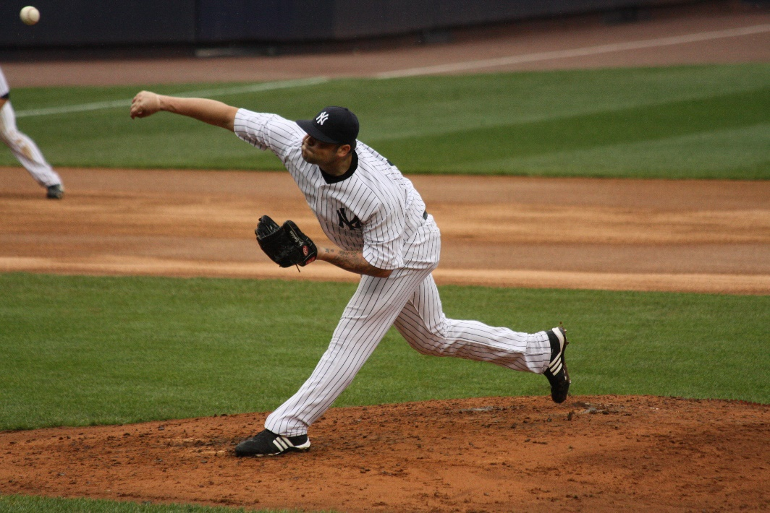

|  |  |
| --- | --- |
| Description | **Max 3 Marks** |
| Shoulder – Flexion / Rotation | 1 mark |
| Elbow - Extension | 1 mark |
| Wrist - Pronation | 1 mark |

**Question 23 (4 marks)**

The body consists of three types of blood vessels: arteries, veins and capillaries. Compare and contrast **two (2)** characteristics of veins and arteries.

|  |  |
| --- | --- |
| Marks | Possible answers |
| 1 mark each characteristic | Characteristic 1  Arteries have thick elastic walls. Veins have thin, less elastic walls.  Characteristic 2  Arteries carry blood away from the heart. Veins carry blood to the heart.  Characteristic 3  Blood flow in arteries is created by heart beat/pulse. Blood flow in veins is created by muscular contraction.  Characteristic 4  Arteries typically carry blood rich in oxygen. Veins typically carry blood low in oxygen.  Characteristic 5  Arteries do not have valves. Veins contain valves.  NOTE: Answer must mention the characteristic from both arteries AND veins i.e. need to compare and contrast. |

**Question 24 (6 marks)**

Identify the **muscles** A through to F on the diagram below. Answer in the space provided below.

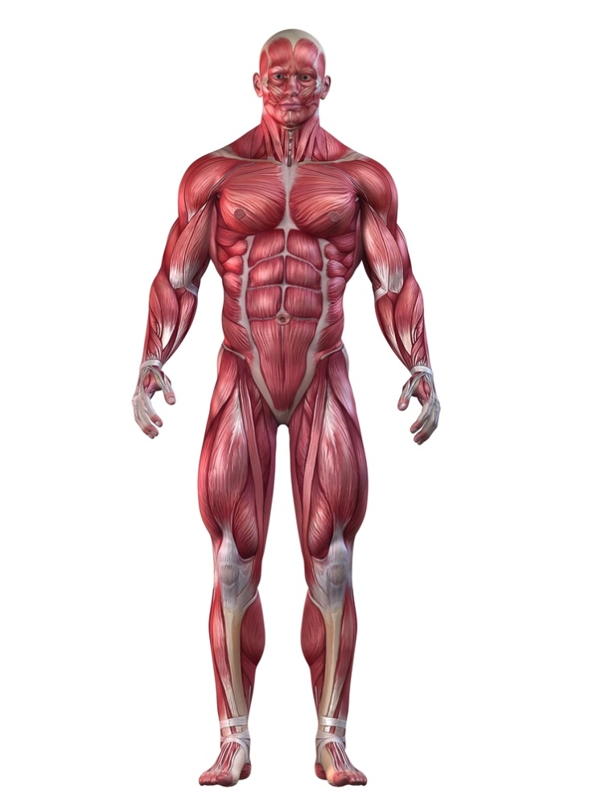

**A**

**B**

**C**

**D**

**E**

**F**

|  |  |  |
| --- | --- | --- |
| **A. Trapezius/sternomastoid** | **B. Deltoid** | **C. Biceps** |
| **D. Abdominals** | **E. Quadriceps** | **F. Tibialis Anterior** |

**Question 25 (3 marks)**

Passing is a fundamental skill of netball. A successful shoulder pass often requires a player to throw the netball with high velocity. Explain how the use of sequential movement can achieve maximal speed in a successful shoulder pass.

|  |  |
| --- | --- |
| Description | **Max 3 Marks** |
| Description of sequential movement (Any three of the following): |  |
| Largest body parts move first in the action, followed by the progressively smaller body parts in the shoulder pass eg. momentum starts with the legs and hips, trunk, shoulder, elbow, wrist, fingers | 1 mark |
| Maximal velocity is achieved in the shoulder pass when each body segment begins movement at the point when the previous body segment has reached maximal/peak velocity, or optimal momentum is achieved through efficient timing of each segment | 1 mark |
| The body needs to be well balanced/sequentially stabilising each segment to aid the transfer of momentum across each body segment. | 1 mark |
| Follow through in the shoulder pass allows acceleration of to be maintained through full range of movement and prevents deceleration until after release of netball | 1 mark |
| All muscular forces are directed to the target to maximise the summation of force and the accuracy of the shoulder pass to the intended receiver. | 1 mark |

**Question 26 (3 marks)**

Golf players use a variety of different clubs to ensure the golf ball travels the required distance. The angle on the club face affects the flight path and trajectory of the golf ball in the air. On the graph below, draw and label the three main trajectories a golf ball could make in its flight path in the air.

High

**Height**

Parabolic

Flat

**Distance**

|  |  |
| --- | --- |
| Description | 3 Marks |
| High trajectory  Parabola trajectory  Flat trajectory | Drawn and labelled correctly the three typical trajectories of a projectile.  (1 mark each) |

**Question 27 (2 marks)**

To achieve maximum horizontal distance, a projectile should be released at a 45⁰ angle. Other than shot put, explain one sporting example where it is necessary to have an angle greater than 45⁰, and one example where it is necessary to have an angle less than 45⁰.

|  |  |
| --- | --- |
| Marks | Possible answer |
| 1 mark  1 mark | **Greater than 45⁰**   * Appropriate example where landing height is higher than release point e.g. basketball free throw   **Less than 45⁰**   * Appropriate example where landing height is lower than release point e.g. hammer throw |

**Question 28 (3 marks)**

Define the terms positive, negative and zero acceleration and provide an example of each during a 200-metre freestyle swim.

|  |  |
| --- | --- |
| **Marks** | **Elaboration** |
| 1 mark – must have both defn and example | *Positive Acceleration*  Definition – the moving body is increasing in velocity (or similar)  Example – Leaving the blocks, first 2-5 strokes before reaching top speed |
| 1 mark – must have both defn and example | *Negative Acceleration*  Definition – the moving body is decreasing in velocity (or similar)  Example – Touching the wall before tumble-turn or end of race or final stages of race when fatigued |
| 1 mark – must have both defn and example | *Zero Acceleration*  Definition – the moving body is maintaining a constant velocity (or similar)  Example – Approx10 metre mark to the 45-metre mark of each lap (once top speed has been reached and before slowing for tumble-turn) |

**Question 29 (4 marks)**

Using examples, explain **two (2)** types of balance a gymnast may display during a floor routine.

|  |  |
| --- | --- |
| Marks | Possible answer |
| 1 mark  1 mark | **Static balance**  Ability to maintain equilibrium while stationary  Example – Handstand or suitable example |
| 1 mark  1 mark | **Dynamic balance**  Ability to maintain equilibrium while moving  Example – performing a series of somersaults or suitable example |

**Question 30 (6 marks)**

Using specific examples, identify **three (3)** types of motion in the picture below.

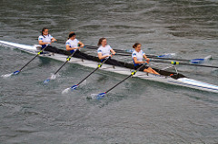

|  |  |
| --- | --- |
| Marks | Possible answer |
| 1 mark definition  1 mark example | * **Linear motion: This occurs when the whole body moves the same distance at the same time in the same direction.**   Any suitable example of movement in a straight line e.g. the boat |
| 1 mark definition  1 mark example | * **Angular motion: This motion occurs when the body moves around an axis of rotation.** * **All body parts involved travel through the same angle.**   Any suitable example of movement around an axis e.g. shoulders |
| 1 mark definition  1 mark example | **General motion: Combination of both**  Any suitable example of movement combing both linear and angular motion e.g. the rower’s body |

**Question 31 (2 marks)**

Athletes require multiple types of feedback to improve their performance. Explain the difference between internal and external feedback when performing a skill.

|  |  |
| --- | --- |
| Description | Max 2 marks |
| **Internal feedback** – Received from sensory receptors inside muscles, joints and tendons which provide information to the athlete about their execution of the skill. eg. Proprioception, kinaesthetic awareness | 1 mark |
| **External feedback** – Is the information received from outside the body. It is received by the sensory system and is seen, felt or heard. eg. Verbal feedback from coach / teammates / crowd / scoreboard results related to execution of the skill / video footage. | 1 mark |

**Question 32 (4 marks)**

Identify the **bones** on the diagram below. Answer in the space provided.

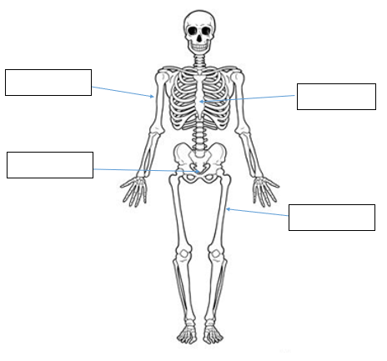

Femur

coccyx

Sternum

Humerus

**Question 33 (4 marks)**

Western Australia’s Jackson Symonds of Sorrento SLSC claimed a record fifth Open Beach Sprint title at the 2019 National Surf Lifesaving Championships. Successfully winning sprint running races requires a fast start. Using your understanding of the information-processing model, explain how Jackson would successfully get a way to an explosive start in the sprint.

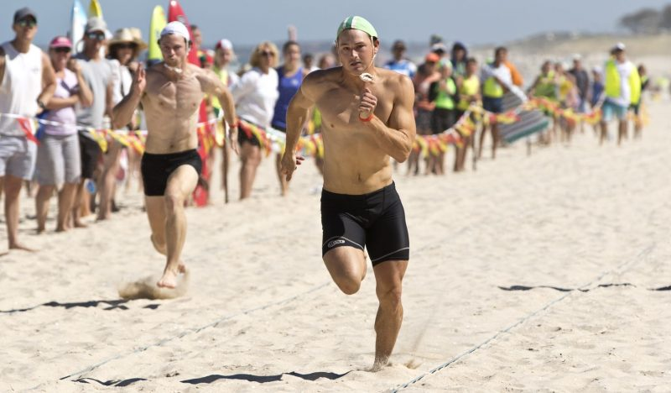

|  |  |
| --- | --- |
| **Description** | **Max 8 Marks** |
| **Stimuli/input stage**  Information is gathered from internal and external sources.  Stimulus detection of cues within the sporting environment. | 1 mark **explaining** stage |
| Jackson gathers information from external cues via hearing the starters gun (ears detect sound) | 1 mark description linking to the start of the race |
| **Response identification/ Decision making / Processing stage**  Information is processed / interpreted / analysed, and a response is selected.  Recognition of stimulus or response identification after processing the information or deciding how to respond to stimuli. | 1 mark **explaining** stage |
| Jackson’s brain recognises the starting gun and decides to trigger nerve impulse to activate muscle contractions to start movement after processing information. | 1 mark description linking to the start of the race |
| **Response / Output stage**  The muscular system carries out the movement or prepare and organise the muscular system to produce the required movement.  Selected movement is produced. | 1 mark **explaining** stage |
| Jackson’s legs muscles are activated to contract forcefully / start fast movement of running action to begin race | 1 mark description linking to the start of the race |
| **Feedback stage**  Information about the performance is received from the selected response.  Comparison of the performance against the desired performance. | 1 mark **explaining** stage |
| Jackson notices his reaction time was fast and he begins the race in a strong position out of the start line or provided with peripheral visual information as to the success of the start in relation to fellow competitors. | 1 mark description linking to the start of the race |

**Question 34**

**(4 marks)**

Cyclists in the Tour de France cycling race compete in teams and have support vehicles which provide nutrition, technical equipment and coaching support. Information on the race is also communicated via in-ear radio which provides feedback aiding in the potential success of the cycling team. Explain **two (2)** purposes of providing feedback to cyclists in such a race as the Tour de France.

|  |  |
| --- | --- |
| Description (Any two of the following) | Max 4 marks |
| **Feedback for reinforcement**  Reinforce what has been achieved so that cyclist can repeat what is required in team tactics / race finish  **Feedback for motivation**  Providing positive feedback to support, encourage, recognise cyclist and/or their efforts  **Feedback to modify performance**  Providing constructive feedback about positive aspects and areas to improve within the race. (eg. Upcoming mountain / sprint stage section) | 1 mark for purpose  1 mark for explanation  1 mark for purpose  1 mark for explanation  1 mark for purpose  1 mark for explanation |

**Question 35 (7 marks)**

Motor skills can be classified according to a number of different factors, including the amount of muscle involvement and the effects of the environment.

(a) Explain the difference between gross and fine motor skills and provide a volleyball example of each. (3 marks)

|  |  |
| --- | --- |
| **Marks** | **Elaboration** |
| 1 mark  1 mark  1 mark | Explain difference – Gross motor skills involve large powerful movements using numerous, large muscle groups whereas fine motor skills involve delicate movements of small muscles (or similar)  Gross examples – choose from (or similar)   * Jump serve, spike, block, dive   Fine examples – choose from (or similar)   * Stationary set, net tip, stationary dig |

(b)(4 marks)

Place the following activities (A, B, C, D) on the continuum below.

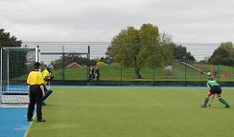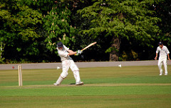

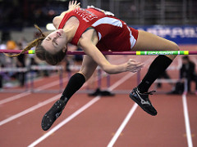

1. Cricket stroke **B**. Penalty stroke (green shirt)

**C**. High jump **D**. Surfing

High jump C

Cricket stroke A

Penalty stroke B

Surfing D

**OPEN CLOSED**

**2 marks for correct answers**

**Extended Answer (20 marks)**

This section contains three (3) questions. **You must answer two (2) of these questions.** Write your answer in the spaces provided.

Spare pages are included at the end of this booklet. They can be used for planning your responses and/or additional space if required to continue an answer.

* Planning: if you use the spare pages for planning, indicate this clearly at the top of the page.
* Continuing an answer: If you need to use the space to continue an answer, indicate in the original space where the answer is continued, i.e. give the page number. Fill in the number of the question that you are continuing to answer at the top of the page.

**Question 36**

From the point of inhalation, describe the mechanics of breathing, including pressure change and flow of oxygen through the cardiorespiratory system to supply oxygen to the working muscle/s.

|  |  |
| --- | --- |
| Marks | Possible answer |
| 1 mark for identification of 8 **structures**  must appear in correct order  2 marks for pressure change | * **Diaphragm** contracts/moves downward to increase space available * **Ribs** rise to increase space available * Oxygen enters the body via the **mouth/nose** * **Lungs** expand/fill with air. Oxygen travels down through the **pharynx, larynx** and **trachea** into the **bronchi** and **bronchioles**. * Gas exchange occurs at the **alveoli** * *Pressure change* – Oxygen pressure in the alveoli is higher than that in the surrounding capillary. As a result, oxygen will move from an area of high pressure to an area of low pressure i.e. from the alveoli to the capillary, via diffusion. * Oxygen returns to the heart via the **pulmonary veins**. * Blood enters the **left atrium**, * Followed by the **left ventricle**. * Blood exits the heart via the **aorta** to travel to the **working muscles** to exchange oxygen, carbon dioxide and waste products |

**Question 37 (10 marks)**

1. Using the three (3) athletes pictured below, discuss how the muscle fibre types

would vary for each athlete. In your answer, state each muscle fibre, include the

muscle fibre ratio of each.

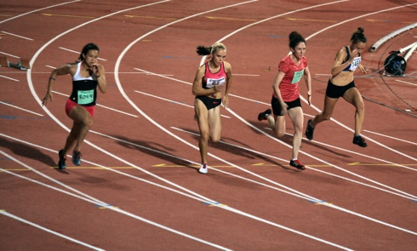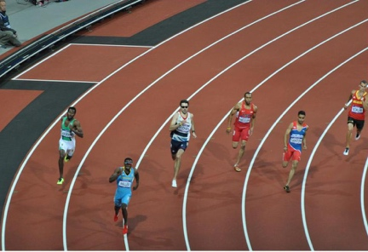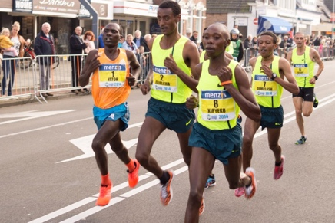

400m sprinter

Marathon runner

100m sprinter

(3 marks)

|  |  |
| --- | --- |
| Description | Marks |
| 100m sprinter would have a very high percentage of Type IIB fibres | 1 |
| 400m sprinter would have a very high percentage of Type IIA fibres | 1 |
| Marathon runner would have a very high percentage of Type I fibres | 1 |
|  |  |
| Characteristics of each fibre type (max 2 per fibre type = 2 marks). The characteristic **must** relate to improving the athletes performance in the given event |  |
| Type II B fibres  Any 2 of the following   * Rapid contraction speed * Very High force production * Very large in diameter * Very large motor neuron * Very high glycolytic capacity | 2*1 |
| Ratios of fibres  80:20  60:40  20:80 | 2*1 |
| Type I fibres  Any 2 of the following   * High capillary density * High oxidative density * High mitochondrial density * Slow contraction speed * Low force production * Fatigue resistant | 2*1 |

1. Discuss how each of Newton’s three (3) Laws relate to the 100m sprint.

|  |  |
| --- | --- |
| Description  1 mark for definition  1 mark for application to running sprint  1mark for naming all newtons laws | Marks |
| Newtons 1st law - A body continues in its state of rest or state of motion unless acted upon by a force  Application of Newtons 1st law – runner remains on starting block until force is created through contraction of muscles  Other relevant examples accepted | 1-2 |
| Newtons 2nd law - The acceleration of a body is proportional to the force applied to it, and inversely proportional to the mass of the object  Application of Newtons 2nd law – increase application of force in opposite direction results in greater acceleration  Other relevant examples accepted | 1-2 |
| Newtons 3rd law - For every action, there is an equal and opposite reaction  Application of Newtons 3rd law – pushing off the starting blocks, an equal and opposite force is applied sending the runner forward  or  runner applies a downwards and backwards force against the ground and the ground applies an equal and opposite force against the runner propelling them upwards and forwards  Other relevant examples accepted | 1-2 |

(7 marks)

**Question 38 (10 marks)**

The three golfers pictured below are in different phases of their golf career. The child pictured on the left is attempting to hit a golf ball for the first time, the recreational golfer pictured in the middle is working to improve his game, while the adult pictured to the right is playing in a professional tournament.

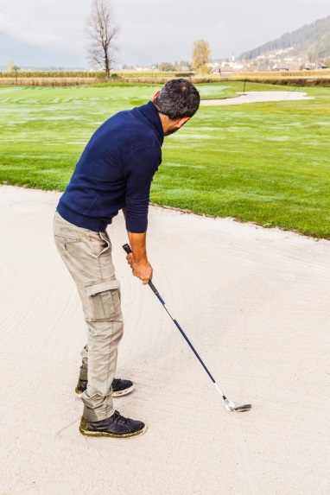

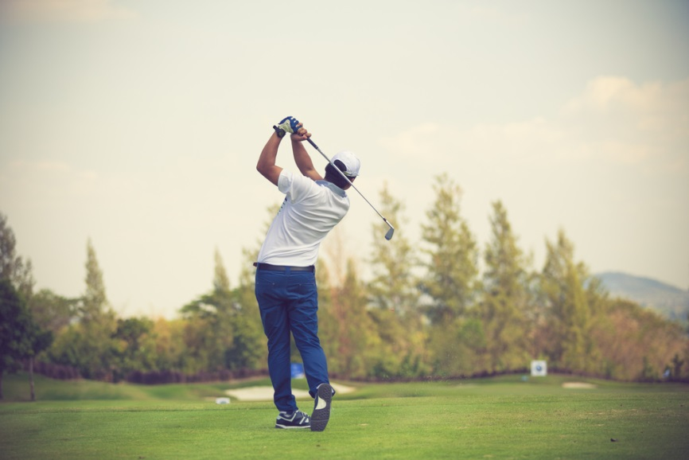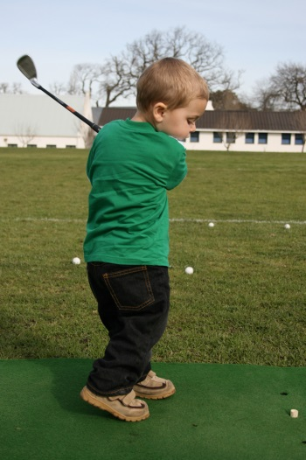

According to the Fitts and Posner model of skill learning, explain the three phases a golfer would move through as they progress from beginner level through to professional. In your response, identify the performance characteristics and type of feedback the learner would require in each phase to maximise their skill learning. Also identify the phase you would expect the golfer to spend the shortest amount of time in.

|  |  |
| --- | --- |
| **Marks** | **Elaboration** |
| 1 mark | Identifies ‘cognitive phase’ as the phase expected to spend the shortest amount of time in |
| 3 marks max  1 mark  1 mark  1 mark | *Cognitive Phase*  Explanation – Phase in which the learner has little understanding of the skill and how to perform it  Characteristics – Inconsistent/erratic performance, many large-scale errors  Feedback required – concurrent, verbal and non-verbal feedback required to correct errors |
| 3 marks max  1 mark  1 mark  1 mark | *Associative Phase*  Explanation – Phase in which the learner understands how to complete the skill and is practicing to improve their performance  Characteristics – Learner makes less errors and performance is becoming more efficient and consistent  Feedback required – more specific augmented feedback or learner begins to use internal feedback to recognise their own errors |
| 3 marks max  1 mark  1 mark  1 mark | *Autonomous Phase*  Explanation – Phase in which the learner has mastered the skill  Characteristics – Able to complete the skill fluently, accurately and consistently with minimal errors and high levels of speed/power  Feedback required – augmented feedback directed towards strategy rather than skill learning or internal feedback utilised to correct own errors |

**End of paper**